SUPERMARKET SALES ANALYSIS

INTRODUCTION
Supermarket Sales Analysis is an analysis done with a three month dataset gotten from Kaggle to find business insights and to understand the sales performance and customer purchasing behavior for each of the branches owned by the supermarket. We'll delve into key areas of analysis, including descriptive statistics, trend analysis, customer behavior, financial insights, and ratings analysis. By leveraging this data, we can uncover valuable information to inform strategic decisions and improve business outcomes.

OBJECTIVES
The objectives of this analysis are as follow:
- Get basic information about the dataset to understand its structure.
- Determine the branch with the highest total sales and ratings.
- Analyze whether membership affects purchase amounts.
- Find out which product categories are generating the most revenue.
- Examine the distribution of customer satisfaction ratings.

DATA AND TOOLS
Most columns are self-explanatory. Branch and City indicate which store made the sale, Customer Type shows if the customer is a member of the supermarket's loyalty program, Product line is the category of items purchased, Total is the total bill amount, Gross Margin Percent is a the profitability metric that shows how much sales revenue is left over and Rating is a customer satisfaction score (1–10) given at the time of purchase. The tools to be used for this analysis is Python(with panda for data handling, matplotlib/seaborn for visualization.
ANALYSIS STEPS
We loaded the dataset using pd.read_csv and conducted an inspection on the data using .head,.shape,.info,.duplicated().sum() to know the basics of the data and to get the mean,meadian,min and max of the data..isnull().sum() to check if there is any null data in the dataset.
We also did the following analysis:
- DESCRIPTIVE ANALYSIS: which includes summary statistics(calculate means, medians, and standard deviations for numeric columns(e.g unit price, quantity, total and rating) and understand customer demographics(e.g gender, customer type),branch and city performance(analyze sales performance by branch and city), product line insights(evaluate which product line generates the most revenue, highest rating, or greatest sales volume) and payment trends(explore which payment methods are most popular).
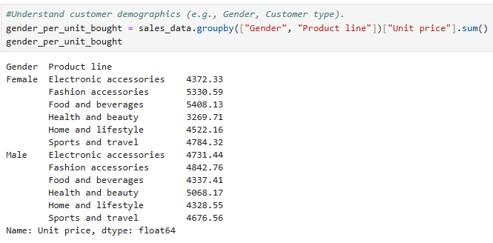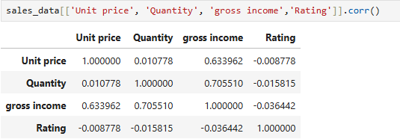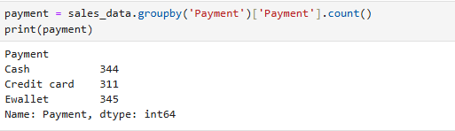
- TREND ANALYSIS: which includes time series analysis(use time, month, day of the week, or year to track sales trends over time and identify peak sales hours or days) and seasonality(analyze sales fluctuations by month or day of the week).
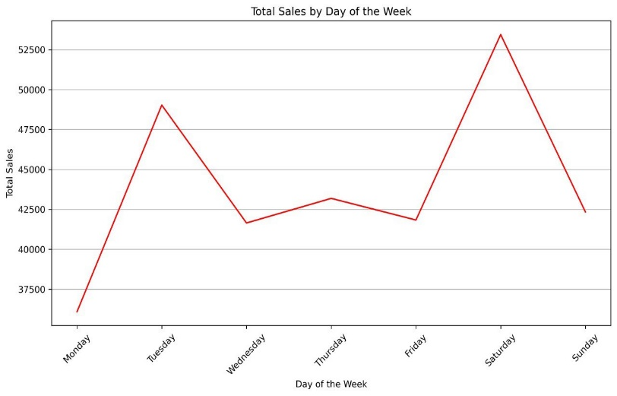
- CUSTOMER BEHAVIOR: which includes customer type analysis(compare purchasing patterns of different customer type groups) and gender analysis(examine if purchasing behavior varies by gender).
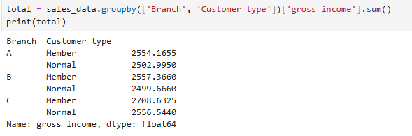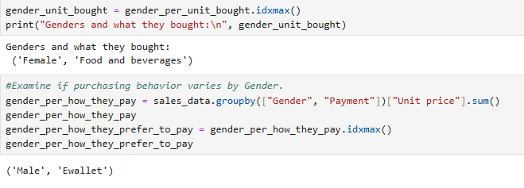
- FINANCIAL INSIGHTS: it includes tax and revenue(calculate total tax revenue(tax 5%) and gross revenue from total), profitability"(use cogs(Cost of goods sold) and gross income to calculate profitability metrics) and gross margin analysis(investigate the gross margin percentage for each product line or branch).
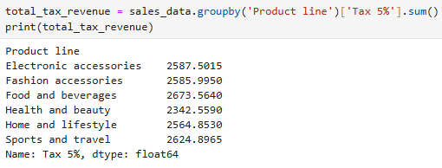
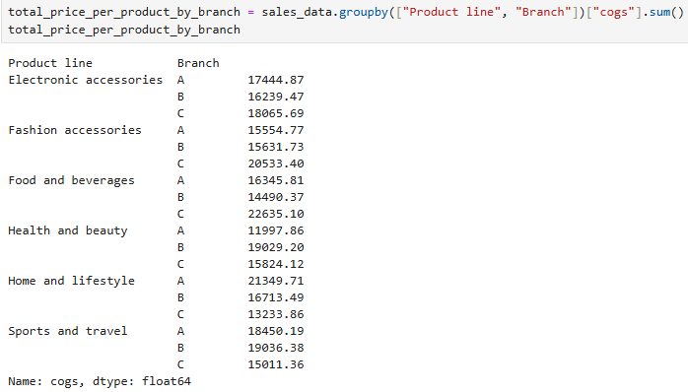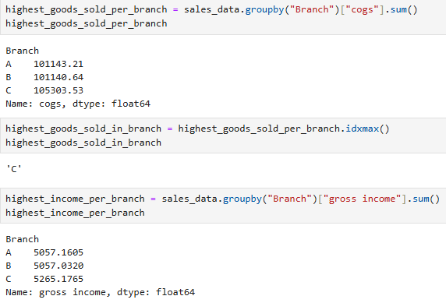
- RATING ANALYSIS: includes product ratings(analyze customer rating across product line or branch) and correlation"(explore relationships between rating and other variables e,g total, payment).
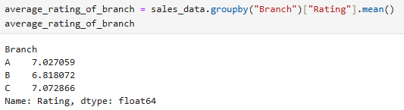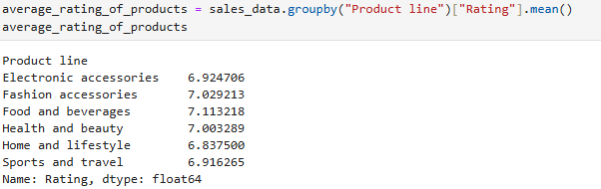
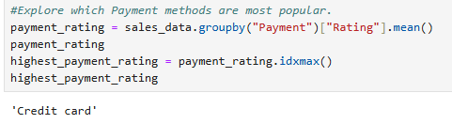
- ADVANCED ANALYTICS: includes predictive modeling(use the data to predict sales, customer churn or high-rated product lines), segmentation(cluster customers or transactions using variables like product line, total, payment or rating) and optimization(recommend pricing or promotional strategies based on sales trends).
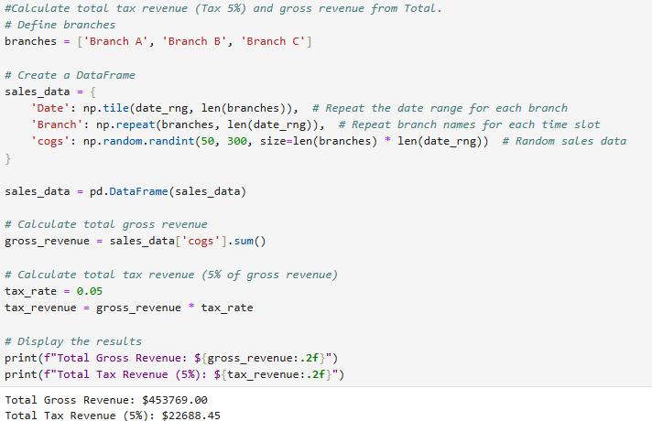
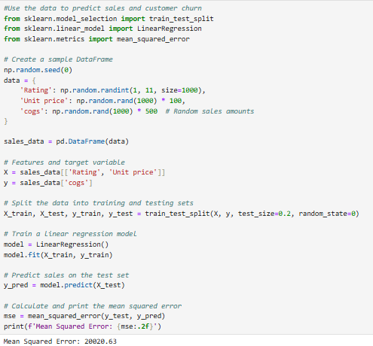
- VISUALIZATION: includes bar charts(sales by branch, city or product line), line charts(time based trends for Total or Quantity), heatmaps"(Correlation between numeric features like unit price, tax 5%, cogs and gross income) and pie charts(breakdown of payment methods or gender).

VISUALIZATIONS AND FINDINGS
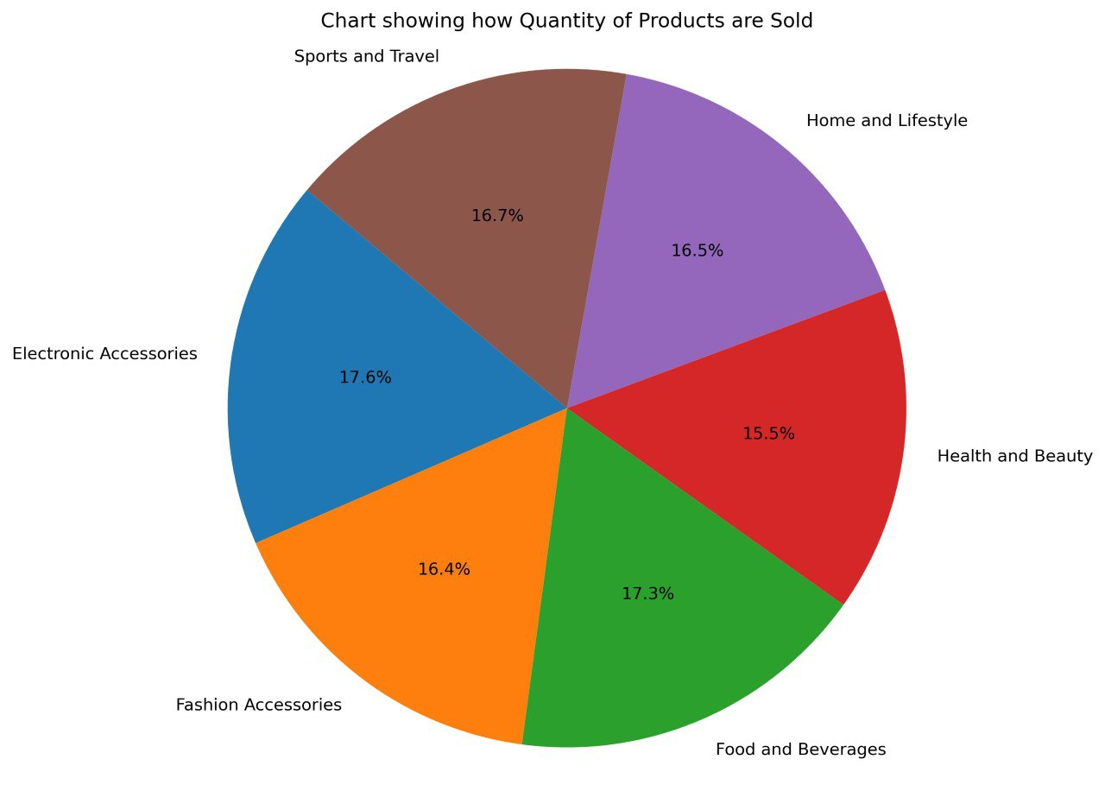
From the visualization above it’s seen that the Top 3 selling products are: Electronics Accessories by 17.6% is the highest selling product followed by Foods and Beverages by 17.3% and Sports and Travel by 16.7%. It’s also seen that Health and Beauty is the lowest selling product by 15.5% amongst all other products and it should be promoted more by having discount sales or by advertising the product more to get more visibility.
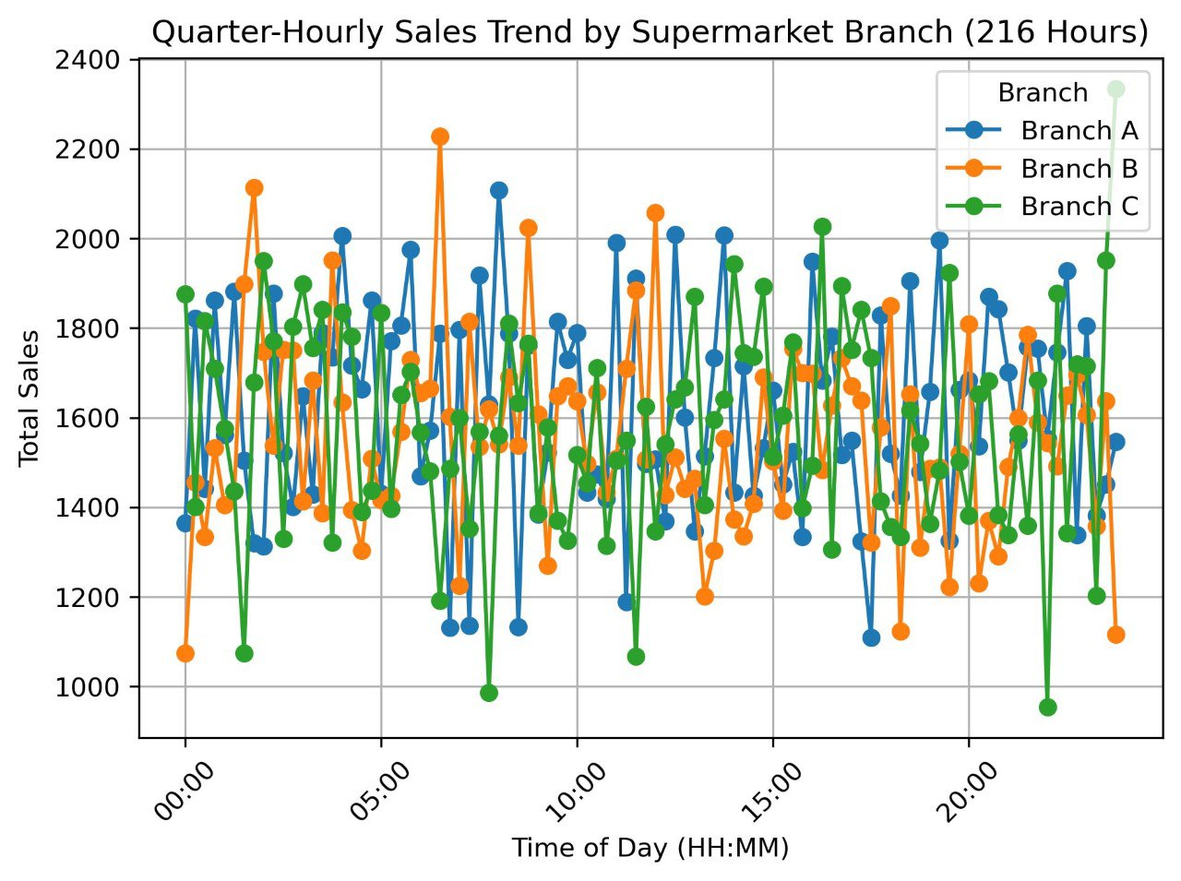
Quarter-Hourly Sales by all the supermarket branches shows the hours the supermarkets are mostly patronized or busy and from the chart it’s shows that Branch C is mostly patronized or busy at night from the hours of 9pm thereabout while Branch B is patronized or busy around the early hours of the morning from the hours of 5:30am thereabout. From this chart we can say that the customers in Branch C prefers to shop during the night hours while those at Branch B prefers shopping during the early hours of the morning.
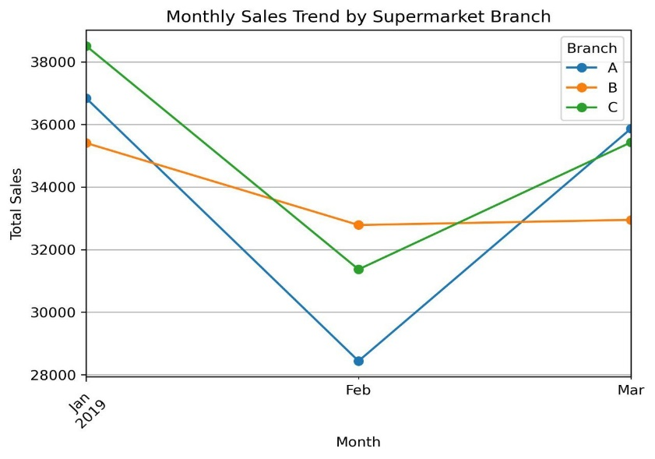
From the chart above it’s seen that there was high sales in the month of January but in February the sales dropped down a lot but came back up a little in the March. Branch C had the highest sales in January while Branch A followed but in March Branch A had the highest sales while Branch C followed. In the Month of February the supermarkets could hold sales on Sports and Travels or Fashion and Accessories or the both products so that people could buy them as gifts for their loved ones or make travel plans since it’s the month of celebrating love that could help increase their sales for that month.

CONCLUSION
In conclusion, we could see from the analysis that Branch C which is Naypitaw is the capital of Myanmar, it is sparsely populated therefore affecting businesses and economic activities. It’s population are mostly filled with Government employees/officials who preferred to shop at the traditional markets where goods are generally cheaper was the leading branch amongst the others, it had the highest rating, highest income, highest cogs and the branch with the highest performing product which was Foods and Beverages. From the Customer Behavior we saw that Females were the highest customers and they bought Foods and Beverages more while the Males preferred paying with E-wallet rather than the other payment methods. Amongst the customer type members patronized the most and also bought Foods and Beverages so it’s safe to make the assumption that the Females were members since they were the highest customers at the supermarket.
Armed with these insights, we can now apply them to a variety of business objectives. We can leverage data to improve sales forecasts, personalize customer experiences, optimize product offerings, and make informed decisions across the organization. This data-driven approach can help us achieve sustainable growth and excel in the dynamic retail landscape.
From our observation while working on the data Branch B which is Mandalay although being the second largest city has the lowest sales, it is located in the Central part of the country. It has a very strategic location as it serves as a key trading center for goods moving between India, China, and other parts of South East Asia. Due to this reason, there is readily available and readily accessible imported goods from China. There are so many supermarkets and malls in the city that attracts young people. So we recommend they work on probably sponsoring festivals or events in the City for them to be known amongst the people and also they could create a website or app for those that want to shop from home and not wanting to leave their comfort zone and the same could be done to other branches to increase income and to move the company forward.
They could also have online and shop sales for their product and also give out sample products to their customers and they could also try to gift their loyal customers at the end of the year. They should also have a market survey and they should also use the internet and media to advertise their products, they should also add that the goods are fresh and cheap in order to gain customers and emphasis on it being cheaper than the traditional market since the traditional market has more customers.

